**CROP DISEASE DETECTION  
(Deep Learning Case Study)**

Srilaasya G – Hu21csen0500075

Amulya M – Hu21csen0500091

Vaishnavi B – Hu21csen0500169

**Problem statement** :

Detecting and managing crop diseases is vital for ensuring food security, yet traditional methods lack efficiency. This project aims to address the challenge by implementing a Convolutional Neural Network (CNN) for automated crop disease detection. The primary challenges include accommodating the variability in disease manifestations across diverse datasets, mitigating limited labeled data issues through techniques like transfer learning, and achieving real-time detection for timely intervention. The model must generalize across different crops, considering variations in plant structures and textures.

**Challenges :**

**Dataset Variability:** Handling diverse manifestations of crop diseases influenced by environmental conditions, plant types, and disease stages.

**Limited Labeled Data**: Overcoming resource-intensive annotation challenges through techniques like transfer learning and data augmentation.

**Real-time Detection:** Optimizing CNN models for rapid or near-real-time detection without compromising accuracy.

**Generalization Across Crops:** Developing models that generalize across different crop types despite variations in structures, textures, and disease symptoms.

**Interpretable Results:** Providing transparent and understandable model outcomes to gain trust and facilitate decision-making for non-expert user.

**Applications :**

**Precision Farming**: Application of CNNs in precision farming helps farmers target specific areas affected by diseases, optimizing resource usage and improving overall efficiency.

**Food Security**: CNN-based disease detection contributes to global food security by ensuring healthier crops and reducing the risk of widespread crop failure.

**Automated Pest Management:** Implementing CNNs for disease detection aids in automating pest management strategies, reducing reliance on manual inspection and intervention.

**Research and Diagnosis:** CNNs assist researchers and agronomists in studying and diagnosing crop diseases

**CNN analysis :**

Convolutional Neural Networks (CNNs) play a pivotal role in crop disease detection by autonomously extracting features from crop images, discerning subtle disease indicators. Trained on labeled datasets, these networks swiftly and accurately classify crops as healthy or diseased, enabling timely intervention. Transfer learning enhances performance, especially in data-scarce scenarios. CNNs' real-time capabilities facilitate quick responses to evolving disease patterns, minimizing crop losses. Their interpretability through visualization techniques fosters farmer confidence, making CNNs integral to precision agriculture and crucial for ensuring sustainable farming practices and global food security.

**Architecture :**

A Convolutional Neural Network (CNN) architecture for crop disease detection involves input layers processing pixel data, dense layers, followed by convolutional layers detecting features and activation functions introducing non-linearity. Subsequent pooling layers reduce dimensions, leading to fully connected layers learning global patterns. Dropout and batch normalization enhance regularization. The output layer produces predictions. This structured architecture enables the CNN to effectively analyze crop images, facilitating accurate disease identification and classification based on visual cues within an optimized and learned framework.

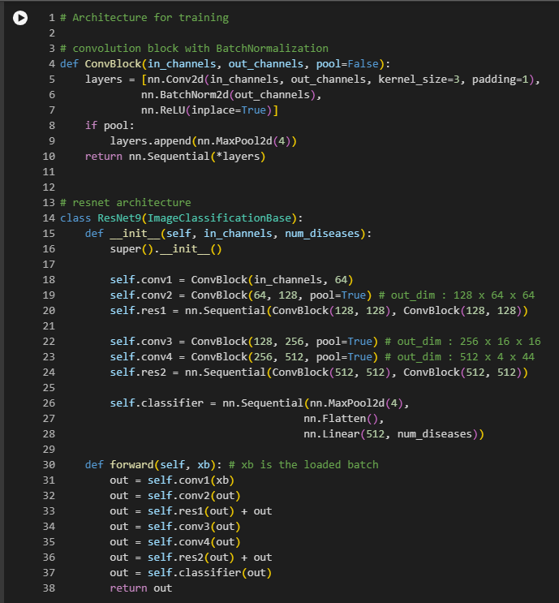

**Hyper parameter tuning :**

In hyperparameter tuning for crop disease detection, crucial parameters like learning rate, batch size, network architecture, dropout rates, and regularization strength are systematically adjusted. Techniques such as grid search or random search are employed to optimize these parameters, aiming to minimize the model's loss function. The objective is to enhance the machine learning model's accuracy in identifying and classifying crop diseases, ensuring robust performance across diverse agricultural scenarios. Fine-tuning these hyperparameters is vital for the development of an effective and reliable crop disease detection system with optimal generalization capabilities.

**Accuracy :**

The accuracy of crop disease detection models can vary based on factors such as the dataset quality, model architecture, and hyperparameter settings. State-of-the-art models using Convolutional Neural Networks (CNNs) can achieve high accuracy rates, often exceeding 90%.

**Confusion matrix:**

A confusion matrix is a table that summarizes the performance of a classification algorithm. It shows the number of true positives, true negatives, false positives, and false negatives. The rows of the matrix represent the actual classes, while the columns represent the predicted classes. It is a useful tool for understanding the strengths and weaknesses

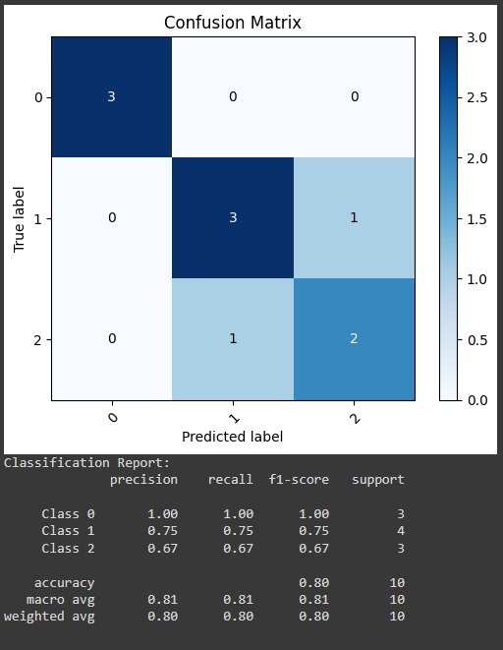

**Data set used :**

<https://www.kaggle.com/datasets/vipoooool/new-plant-diseases-dataset>

**Experimentation :**

<https://colab.research.google.com/drive/1VAUGgc1sTVBP8FcJC_DnE3i31mluqHGU?usp=sharing>

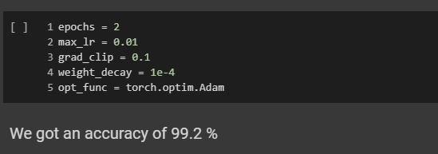

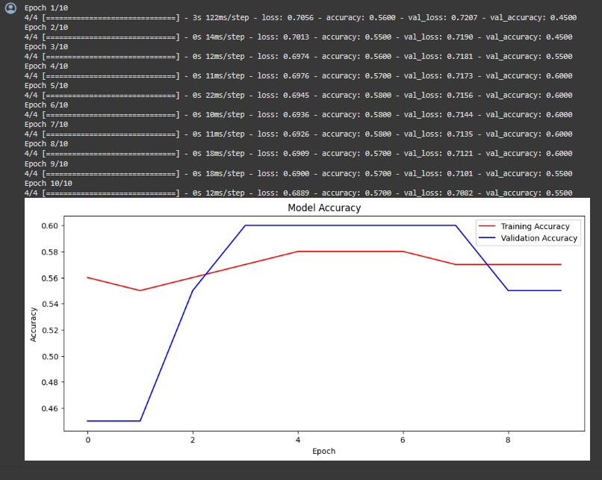

**Conclusion**:

In conclusion, crop disease detection using advanced technologies, particularly Convolutional Neural Networks (CNNs), holds significant promise for revolutionizing agriculture. The ability of CNNs to analyze and interpret visual cues from crop images facilitates early and accurate disease identification, enabling timely intervention and reducing yield losses. While challenges like dataset variability and model generalization persist, ongoing advancements in machine learning and precision agriculture offer opportunities for continuous improvement. As these technologies mature, the integration of robust crop disease detection systems into farming practices stands to enhance global food security by ensuring healthier crops and sustainable agricultural practices.

# References :

* [CIFAR10 ResNet Implementation](https://jovian.ai/aakashns/05b-cifar10-resnet)
* [PyTorch docs](https://pytorch.org/)